Program 4: Library Terminal

Review Topics:
- File Input/Ouptut  - Structs  - Strings | - Arrays  - Functions  - Loops

About
You will implement a system for a library terminal.
When the program starts, it will load in a list of all the library books (ID, title, and author name). Then, the user can log in as an Admin or as a Public user. Admins can add new books, modify existing books, and save the database. The Public can search for books by Author or Title.
We will utilize structs to store Book information and Library functionality in their own objects. These structs will contain their own member variables and member functions. As a result, the main() function of the program should be pretty small.

Sample Output
View the sample program output video at:
https://www.youtube.com/watch?v=HjFan9QFthk

Files Needed
Make sure to download the sample library.txt file that your program will work with.

Functionality Overview
- Import list of library books (ID, Title, Author) from a .txt file
- Export list of library books (ID, Title, Author) to a .txt file
- Allow users to search for a book by Title
- Allow users to search for a book by Author
- Allow admins to add a new book to the list
- Allow admins to update an existing book

String Search
In C++, we can search for a string within another string using the .find(...) function. This function is a member of the string class, and will either return an integer (the position that the match was found), or a -1 (also represented by string::npos). You will utilize this function to search for books by title and author.
Example:
string text = "How are you?";
string lookFor = "you";

if ( text.find( lookFor ) == string::npos )
{
cout << "FOUND" << endl;
}
else
{
cout << "NOT FOUND" << endl;
}

Library text file
You will use the library.txt file to load in a list of books and authors from outside of the progam. Your program will also be able to export the list of books from the program to a text file.
The library.txt file is in the following format:
ID TITLE AUTHOR
100 The_Stupid_Programmer Yu Van Jia
652 A_Sour_Airplane Jeong Yuki Aputsiaq
6076 The_Adorable_Train Ubon Clio Jarmo
6088 The_Squeaky_Artist Qusai Shikoba Heriberto

The first line is a header, which our program should ignore. Then, we can always count on each line containing: ID (int), TITLE (string), and FIRST, MIDDLE, LAST names (string).

Object Design

Book
The book struct will contain three members and two functions:
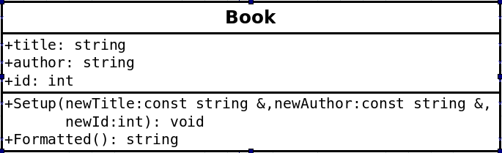
void Setup( const string& newTitle, const string& newAuthor, int newId )
This function will take in 3 parameters and initialize the member variables title, author, and id, to these parameter values.
string Formatted()
This function will create a string that combines the book title and author name and return this string so the book information can be displayed all at once.

Library
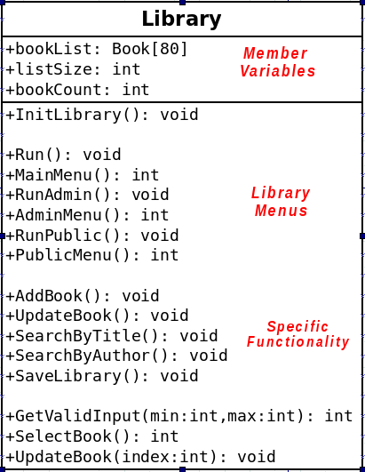 | The Library object will contain an array of Book objects, as well as keep track of the size of the array and the book count.  Additionally, this class will also contain all of the functionality that the library would need, so there will be a lot of functions stored within.  From main(), the Library's Run() function will be called, which will handle displaying a main menu and getting the user's input.  From there, the other functions within Library handle all the options that the user might select.

void InitLibrary()
This function will be called from within main() in order to set up the library by loading in the library.txt file and initializing the member variables of Library.
- Open the library.txt file
- Read in the first 3 items of the text file; these don't need to be stored, as it is just the header.
- Read the rest of the file data, with each line containing: id, title, first name, middle name, and last name.
- Store the information read in, into the bookList array and increment bookCount.
- Initialize the listSize variable to 80.
- Close the input file.

int GetValidInput( int min, int max )
- Get the user's input
- Check to make sure their choice is between min and max
- Continue looping and asking for their input again, while it is an invalid value.
- Once the value is valid, return the user's choice.

int MainMenu()
- Display a main menu with the following options:
  - Public Access
  - Admin Access
  - Exit
- Get the user's input via the GetValidInput function, and return the value.

int AdminMenu()
- Display the following menu:
  - Update book
  - Add book
  - Export database
- Get the user's input via the GetValidInput function, and return the value.

int PublicMenu()
- Display the following menu:
  - Search by title
  - Search by author
- Get the user's input via the GetValidInput function, and return the value.

void Run()
This function will resemble our old programs, where it will contain a while loop that will continue running the program until the user decides to quit.
- Create a while loop that will continue looping until the user decides to quit.
- Call the MainMenu() function and store its result in a variable (such as “choice”). Based on the user selection:
  - If the user selected 1, then call RunPublic()
  - If the user selected 2, then call RunAdmin()
  - Otherwise, break out of the while loop to allow the program to quit.

void RunAdmin()
- Call the AdminMenu() function and store the result in a variable (such as “choice”).
- Check the value of the user's choice:
  - If it is 1, call the UpdateBook() function.
  - If it is 2, call the AddBook() function.
  - If it is 3, call the SaveLibrary() function.

void RunPublic()
- Call the PublicMenu() function and store the result in a variable (such as “choice”).
- Check the value of the user's choice:
  - If it is 1, call SearchByTitle()
  - If it is 2, call SearchByAuthor()

void SaveLibrary()
- Open up a file called library.txt
- Write out the header: ID TITLE AUTHOR
- Iterate through each item in the book list, outputting its ID, Title, and the Author name.
- Close the file.

void UpdateBook( int index )
- Get the user's input for the new title and author's first, middle, and last name.
- Store this information in the correct element, based on the index passed in as a parameter.

void UpdateBook()
- Use the SelectBook() function to get the index of a book from the user.
- Call the UpdateBook( … ) function, passing in the book index.

void AddBook()
- Check to make sure the bookList array is not yet full. If it is full, then display an error and do not add any more books.
- If the array is not full, call the UpdateBook function, passing in the bookCount as the index. Afterward, manually assign the ID of this new book the value of the previous book's ID plus one.
- Add 1 to the bookCount.

void SearchByTitle()
- Have the user input a word that they are searching for in the title.
- Iterate through all of the elements of the bookList array.
- If there is a match, then output this book's ID, title, and author to the screen. (Use the book's Formatted() function).

void SearchByAuthor()
- Have the user input a word that they are searching for in the title.
- Iterate through all of the elements of the bookList array.
- If there is a match, then output this book's ID, title, and author to the screen. (Use the book's Formatted() function).

int SelectBook()
Because there could be many books in the database, we cannot show the user all the items at once. We will implement a rudimentary form of paging, so that they can view a set of 20 books at a time and either choose a book, or go to the next page to view the next 20 books.
- Create a variable called increment, an integer, and set it to 20.
- Create a variable called pages, an integer, and set it to bookCount / increment.
- Create a while loop that will loop forever. It will contain another loop.
  - Create a for loop that loops from 0 to pages (include pages). Use “p” as the iterator variable.
  - Within the page for-loop:
    - Create a variable called first, an integer, and set it to p*increment.
    - Create a variable called last, an integer, and set it to p*increment+increment.
    - Create an internal for-loop for books, which iterates from the value of first to the value of last (do not include last).
      - Display the index, ID, title, and author for each book within this range.
    - After the book for-loop, display a message that the user can enter any other number to go to the next page.
    - If the user selects an item between first (inclusive) and last (exclusive), so that
first <= choice < last
then return the user's choice from the function.

So there is a while loop, with a for-loop for pages within, and a for-loop for books within that. If the user never selects a book the first time through all the pages, the while loop will ensure that it goes back to the first page until the user selects a valid book.

The main program
With all of this functionality stored within the Library class, your main function should look something like this:
#include "Library.hpp"

int main()
{
Library library;
library.InitLibrary();
library.Run();

return 0;
}

Testing the program
Make sure you can do each of these steps in order to test the program:
- After the program is loaded, go to Admin Access > Update book to ensure that the books were loaded, and that you can view all of the books by scrolling through the pages.
- Under Update book, make sure that the function will only return once the user has selected a valid book index. If the user selects an invalid value, it will just go to the next page.
- There should be 78 books loaded at the beginning. Go to Admin Access > Add book, and add two books. Try to add a third, and you should get an error saying that the array is full.
- After adding two books and updating a few existing books, go to Admin Access > Export database to ensure that the library.txt file is updated.
- Go to Public Access > Search by title and make sure titles that match the search term come up. (Note that this is a case-sensitive search).
- Go to Public Access > Search by author and make sure authors that match the search term come up. (Note that this is a case-sensitive search).

